Creating AWS Athena Table from S3 Data

# Introduction

This lab will guide you through the steps to create a table in AWS Athena from data stored in an S3 bucket. By the end of this lab, you will have a functioning Athena table that you can query.

# Let’s get started

### Step 1: Log in to AWS Console

1. Open your web browser and navigate to the <https://us-west-2.console.aws.amazon.com/athena/home?region=us-west-2#/query-editor/history/165880e0-2c30-4392-b1a1-656be5a60d74>

2. Log in with your AWS account credentials.

### Step 2: Navigate to Athena Query Editor

1. In the AWS Management Console, navigate to the Athena service by typing **Athena** in the search bar and selecting it from the results.

2. This will open the Athena Query Editor interface.

### Step 3: Start Table Creation

1. In the Athena Query Editor, click the **Create** button.

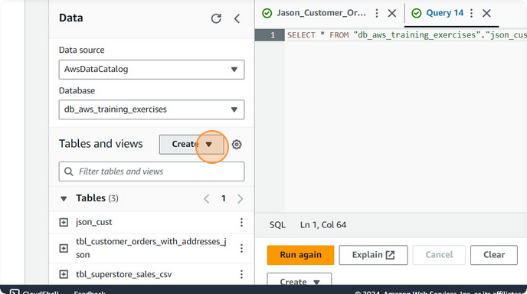

2. Select **S3 bucket data** as the source for your table.

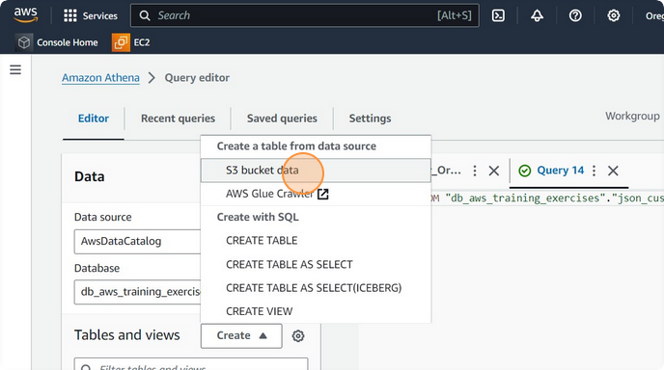

### Step 4: Define Table Name

1. Click the Table name field.

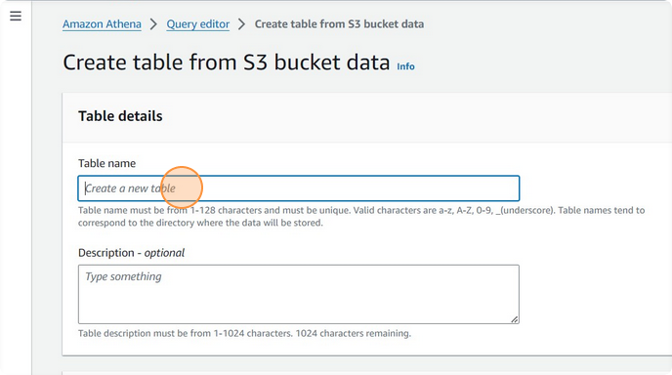

2. Type `tbl_js_Customers_Order` as the table name.

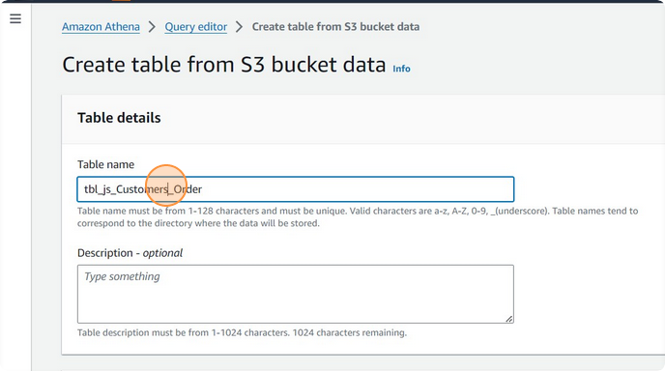

3. Click the **Description - optional** field if you wish to add a description.

### Step 5: Specify S3 Bucket Location

1. Click **Browse S3** to select the S3 bucket containing your data.

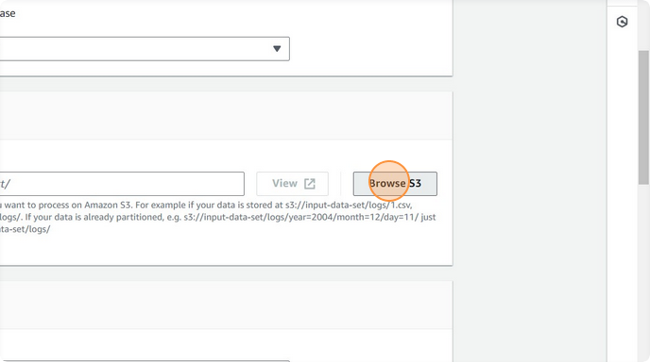

2. Navigate to and select the S3 bucket (e.g., `awstrainingjune01`).

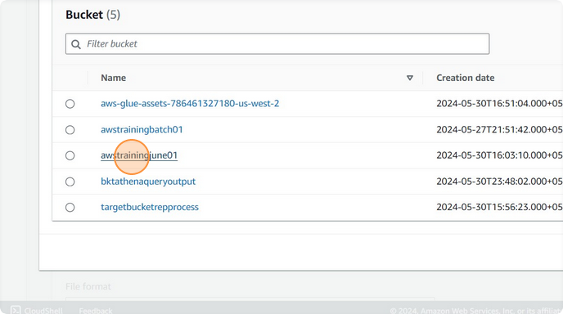

3. Choose the appropriate folder within the bucket (e.g., `Input_Data`).

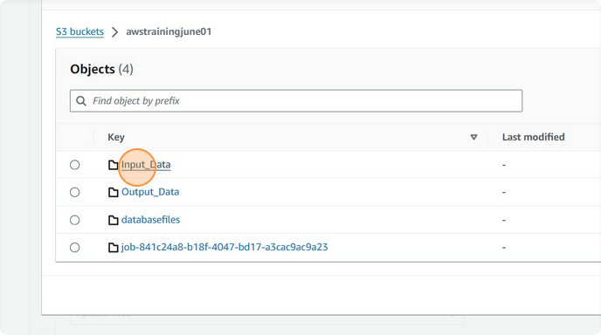

### Step 6: Select File Format

1. Choose the file format of your data. For example, select **JSON** if your data is in JSON format

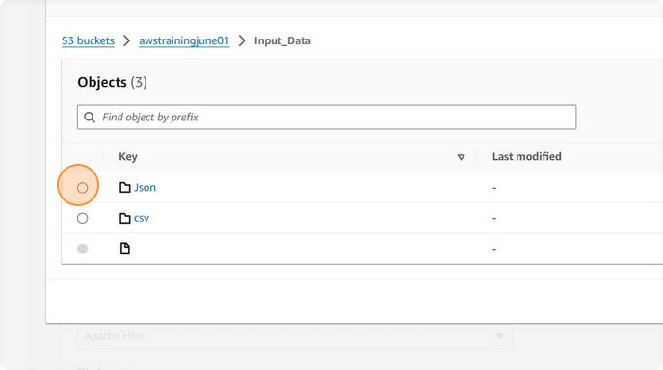.

2. If your data is in a different format like Parquet, select **Apache Parquet**.

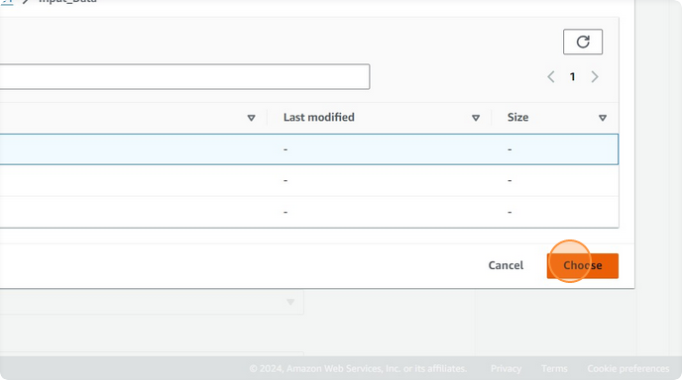

### Step 7: Define Columns and Data Types

1. Switch to the **Table Detail - AWS Glue Console** tab to copy column names and data types.

2. Double-click the first column name (e.g., `order_id`) and press `Ctrl + C` to copy it.

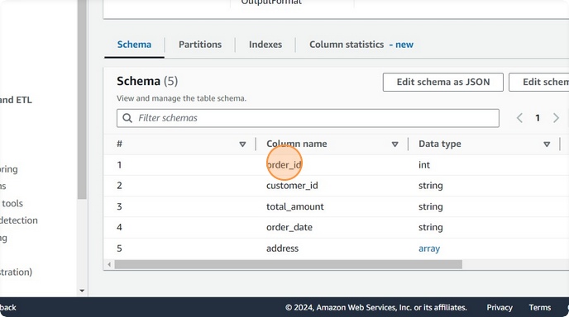

3. Switch back to the Athena Query Editor.

4. Click the **Column name** field and press `Ctrl + V` to paste the column name.

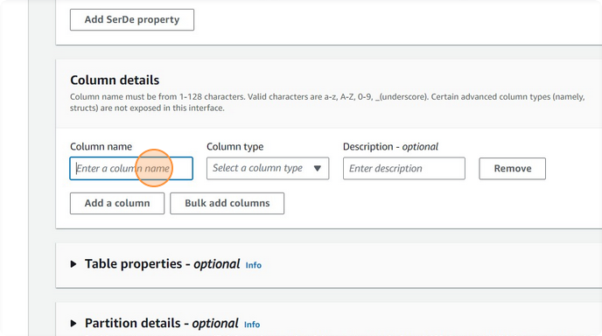

5. Select the appropriate data type for the column (e.g., `int` for integer).

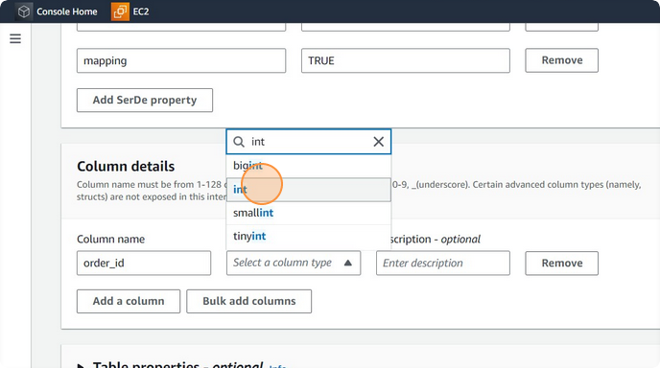

6. Repeat steps 1-5 for each column in your data:

- **customer_id**: `string`

- **total_amount**: `string`

- **order_date**: `string`

- **address**: `array<string>`

### Step 8: Complete Table Creation

1. Once all columns are defined, click the **Create table** button at the bottom of the page.

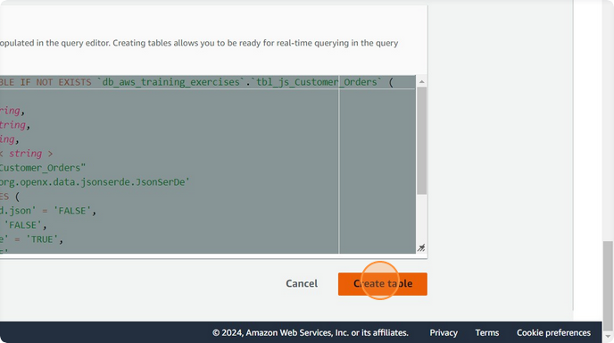

### Step 9: Verify Table Creation

1. After the table is created, you will be returned to the Athena Query Editor.

2. Click **Preview Table** to see a sample of the data from the table.

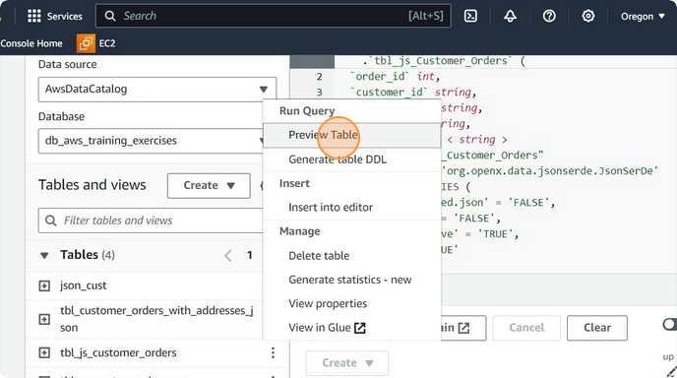

**Voila!!** We have successfully completed this exercise.